P6-Fun Game

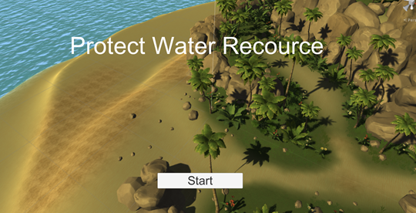

Team 4

Members: Karthik Karra, Jiaxuan Che, Bowen Yuan, Huaizhi Wang, Bhoami Khona.

# 

# Catalogue

**Catalogue** **2**

**Section 1: P1.Final Project Initial Documentation** **4**

1. Game Description 4

2. Key Elements 4

3.Development Tools 5

4.Development Schedule 5

**Section 2: P2 Design Sketches & Paper Prototype** **6**

1. Game Description 6

2. Key Elements 7

3. Visualizing Core GamePlay 9

4. Sketches 9

**Section 3：Game Reflection** **14**

3.1 What We Are Most Proud Of 15

3.2.Changes to Original Game Design 15

3.3.Learned from Playtesters 15

3.4.What Changes would you make based on what you learned from Playtesting 16

3.5.If We Had More Time 16

3.6.What We’d Do Differently 16

**Section 4: Playtesting Discussion** **18**

Game Testing Rubrics 18

Feedback of survey results 19

**Section 5: Reference — P4 Bibliography** **22**

# Section 1: P1.Final Project Initial Documentation

## 1. Game Description

This is a first-person shooter game. The player controls the characters to attack the zombies that appear near the island. There are different levels of zombies moving towards players and water resources. Players need to solve a certain number of zombies before they can pass the level.

### Why do we think this game is an exciting game?

This is a shooting game with 3D first-person shooter game. Players control the shooting of attacking zombies. After killing zombies, players will get gold coins. Gold coins can be used to upgrade firearms and buy bullets. In considering zombie attack and switching bullets, players will enjoy the sense of accomplishment of defeating zombies.

## 2. Key Elements

This game will be played by a single player. The player will control the game characters to resist the attack of zombies and complete the game goals.The purpose of the game is to protect water resources from zombies and to ensure that the game characters will not die. The game has several levels, and players who want to enter the next level must pass and complete the previous level. At the beginning of the game, players will enter level 1 and control the game characters to shoot zombies, which will randomly appear in three different ways. There are 3 types of zombies, each with different blood / life. After the zombie touches the water resources, the game ends. Therefore, players must protect themselves from zombies and kill a certain number of zombies to pass the current level and enter the next level.

## 3.Development Tools

Unity 3D,Xcode Programming,language: C#

## 4.Development Schedule

- Levels (Min Target - Mar 19)

- Alpha Target - Apr 2

- Beta Target Apr 16, (High Target with extras)

- April 16 - April 26 Testing

# 

# Section 2: P2 Design Sketches & Paper Prototype

## 1. Game Description

This is a 3D game. The game takes place in an era of water shortages and virus outbreaks. Deadly viruses can infect people like zombies. Players control game characters to attack zombies who want to contaminate clean water. In different game levels, there are different kinds of zombies moving to the reservoir. Players need to kill a certain number of zombies to enter the next level.

The background of the game is based on the protection of water resources. Now, water supply should become a key issue in many parts of the world. The challenge of water shortages we face is severe. The lack of clean water causes more deaths than wars. About one-sixth of people living today do not have enough water, and more than twice this number lack basic sanitation facilities and therefore need clean water. In addition, existing water purification technologies and methods have certain limitations, and water purification is not easy. Therefore, we should strengthen our understanding of water resources protection.

Our game aims to make people more aware of the protection of water resources, and use different monster images to represent the main sources of water pollution: industrial pollution sources, agricultural pollution sources, and household pollution sources, and design monster properties and difficulties according to the hazards of monsters. . We hope that players can enhance their awareness of protecting net water resources while playing this game.

### Why do we think this game is an exciting game?

This is a 3D first-person shooter game. The attacking pattern of the player-controlled characters is based on a linear movement trajectory. Predicting the speed of zombies and killing zombies to get gold coins can upgrade firearms and buy bullets. Players will more enjoy the sense of accomplishment in defeating zombies.

## 2. Key Elements

### (1)Player

Players control game characters to defeat zombies close to water resources, protect water resources from zombies, and ensure that game characters will not die.

### (2)Player behavior

The player can control the game characters to move freely and can jump and squat. Facing the increased difficulty of each level, players can kill zombies and get gold coins to upgrade firearms and buy bullets.

### (3)Game play Objectives

The purpose of the game is to kill as many zombies as possible while ensuring the safety of water resources and game characters, in order to meet the requirements of game victory.

### (4)Enemy: Monster

Different monster images represent the main source of pollution. As the difficulty of the game increases, the difficulty of defeating monsters also increases. At the beginning of the game, the characteristics and representative meanings of related monsters will be introduced. Players can make money by defeating enemies.

### (5)Procedures or Rules

The game has three levels, and players who want to enter the next level must pass and complete the previous level. At the beginning of the game, players will enter level 1 and control the game characters to shoot zombies, which will randomly appear in three different ways. There are three types of zombies, each with different blood / life. After the zombie touches the water resources, the game ends. Therefore, players must protect the damage of water zombies and kill a certain number of zombies to pass the current level and enter the next level.

### (6)Challenges and Fun

This is a breakthrough game. In order to keep players interested, I plan to enhance the fun and challenge of the game from the following aspects. The first player needs to aim at the zombie to shoot, the player needs to practice mastery and control. Secondly, as the game progresses, the difficulty of different levels will increase, such as the health of monsters, the number and frequency of monsters will increase, and monsters will appear from more directions.

### (7)Color

The main color of the game is planned to be blue and green, mainly to reflect the meaning of cleanliness and cleanliness, and to reflect the image of water resources and pollution-free.

### (8)Resources or Conflicts

Each time you kill a zombie in the game, you will get a different amount of gold coins. Gold coins are resources.

### (9)Boundaries or Formal Elements

Players can freely control the actions of the game characters, and the sight of the firearms is also controlled by mouse movement. Zombies will walk from a specific location on each road.

### (10)Outcome

After killing all the zombies needed for each game, you can win. Once the zombies touch the water resources, the game will fail.

### (11)Artificial Intelligence

When monsters appear from different directions, players will use sound to determine which way zombies appear, and zombies will also have a specific route to clean water. Once the player appears on the route that the zombie passes, the zombie will attack the player. If the player leaves the zombie's movement route, the zombie will continue to move towards the water resources.

## 3. Visualizing Core GamePlay

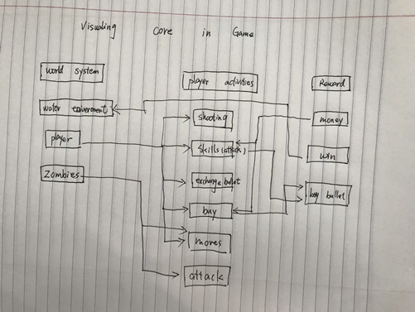

## 4. Sketches

### player interact with the game world

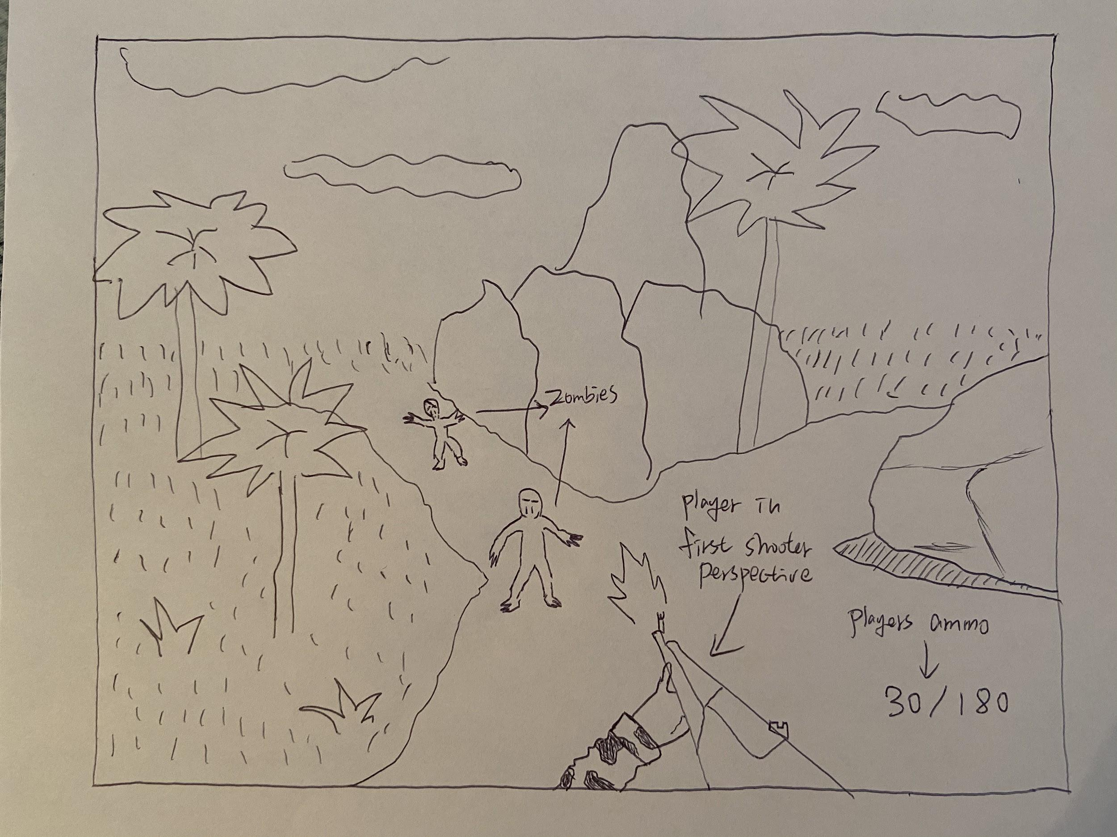

### Game world

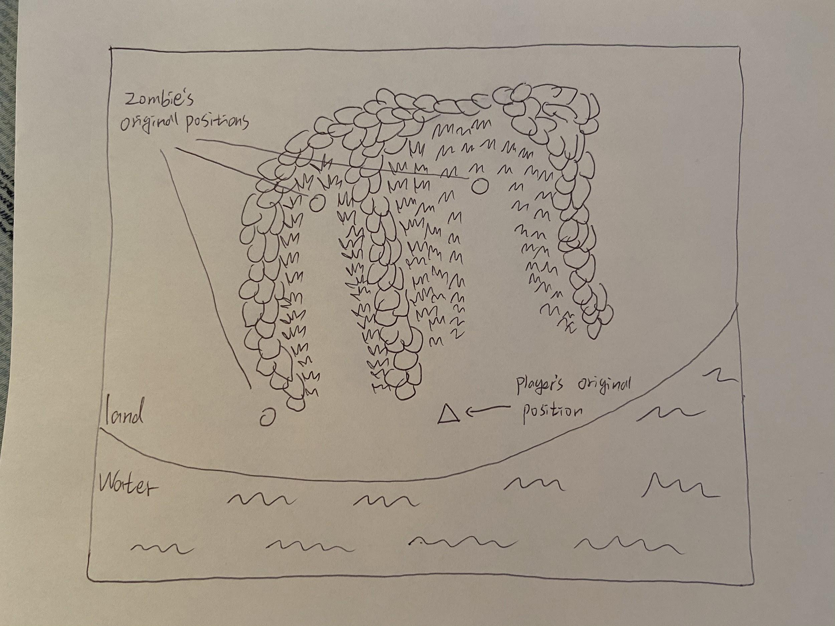

### UI of start page

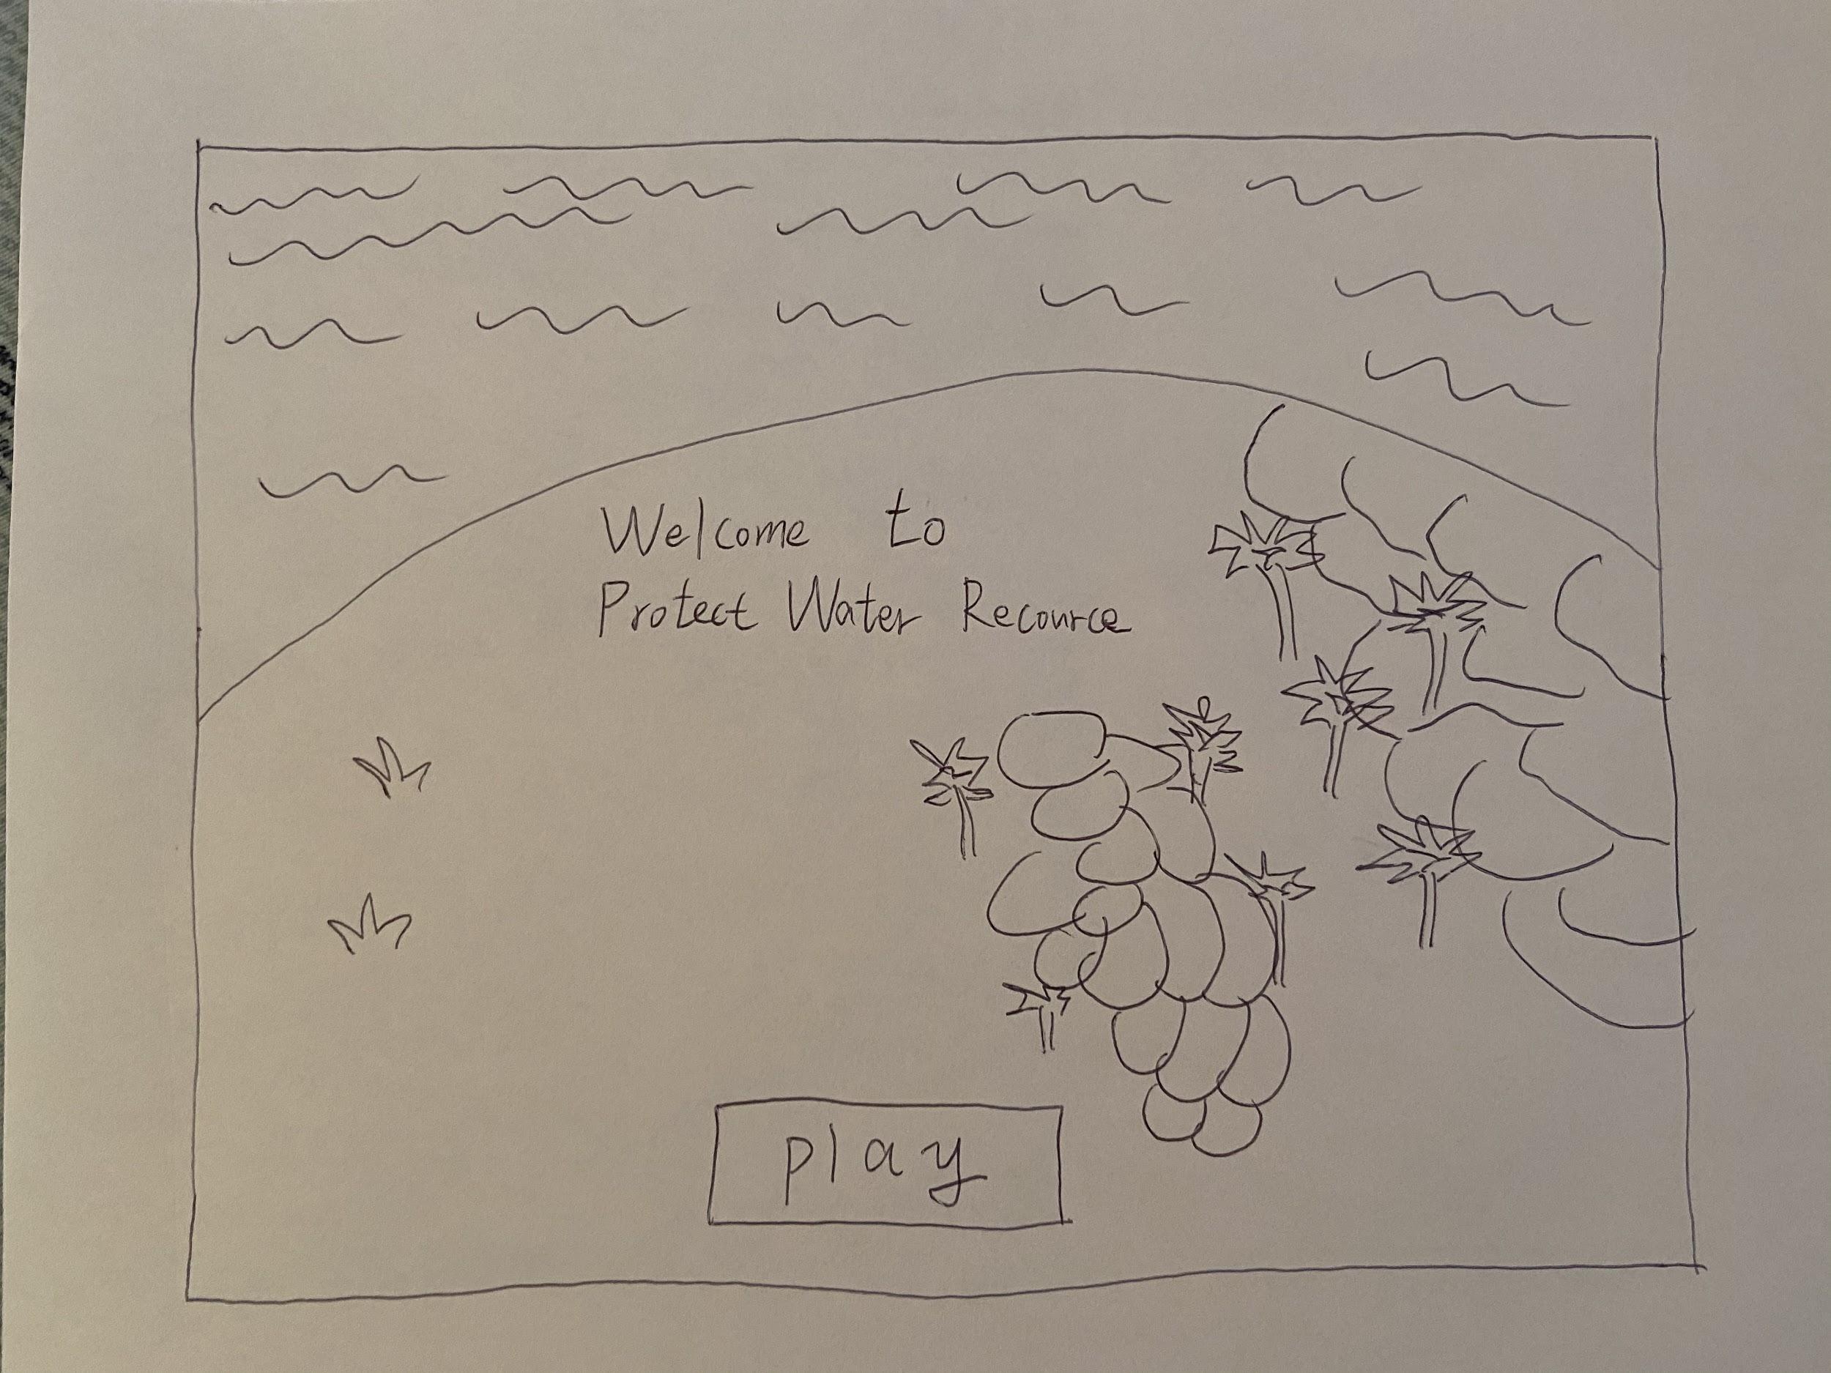

### Enemies’s types

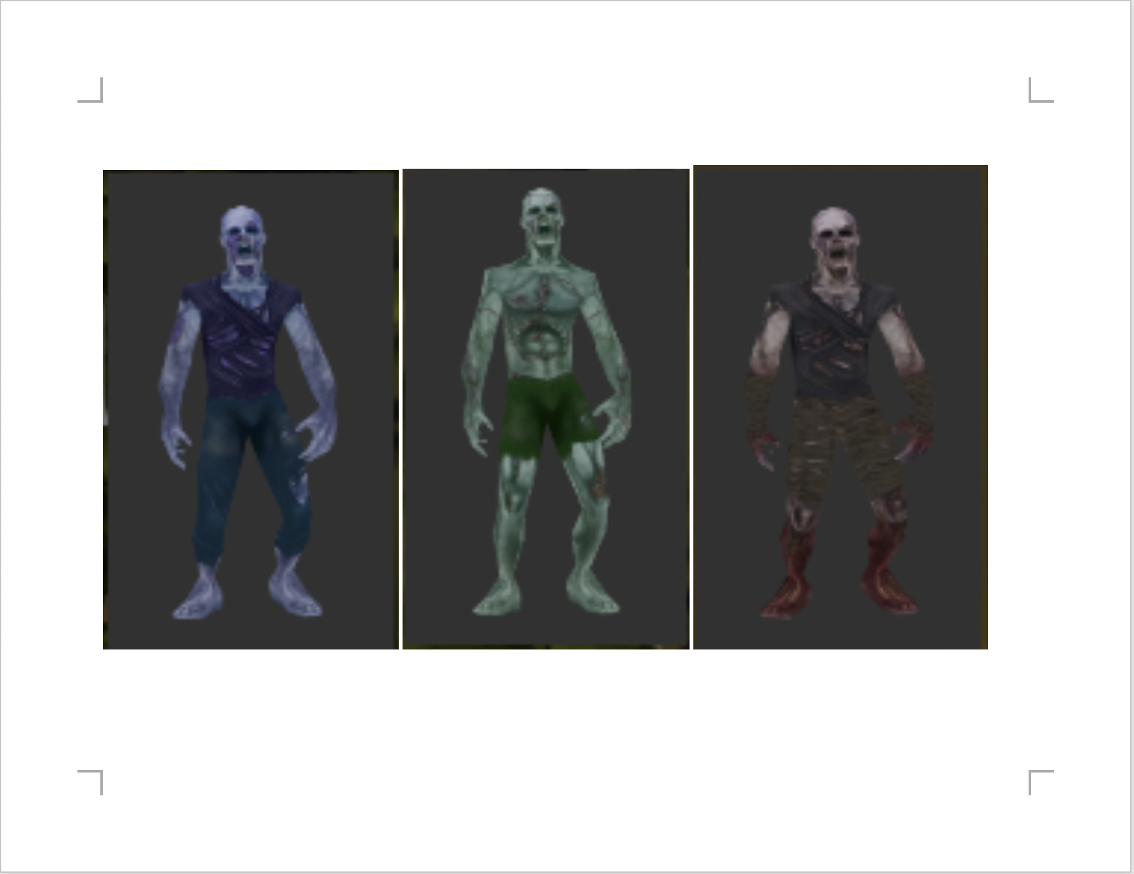

Player choose the game level

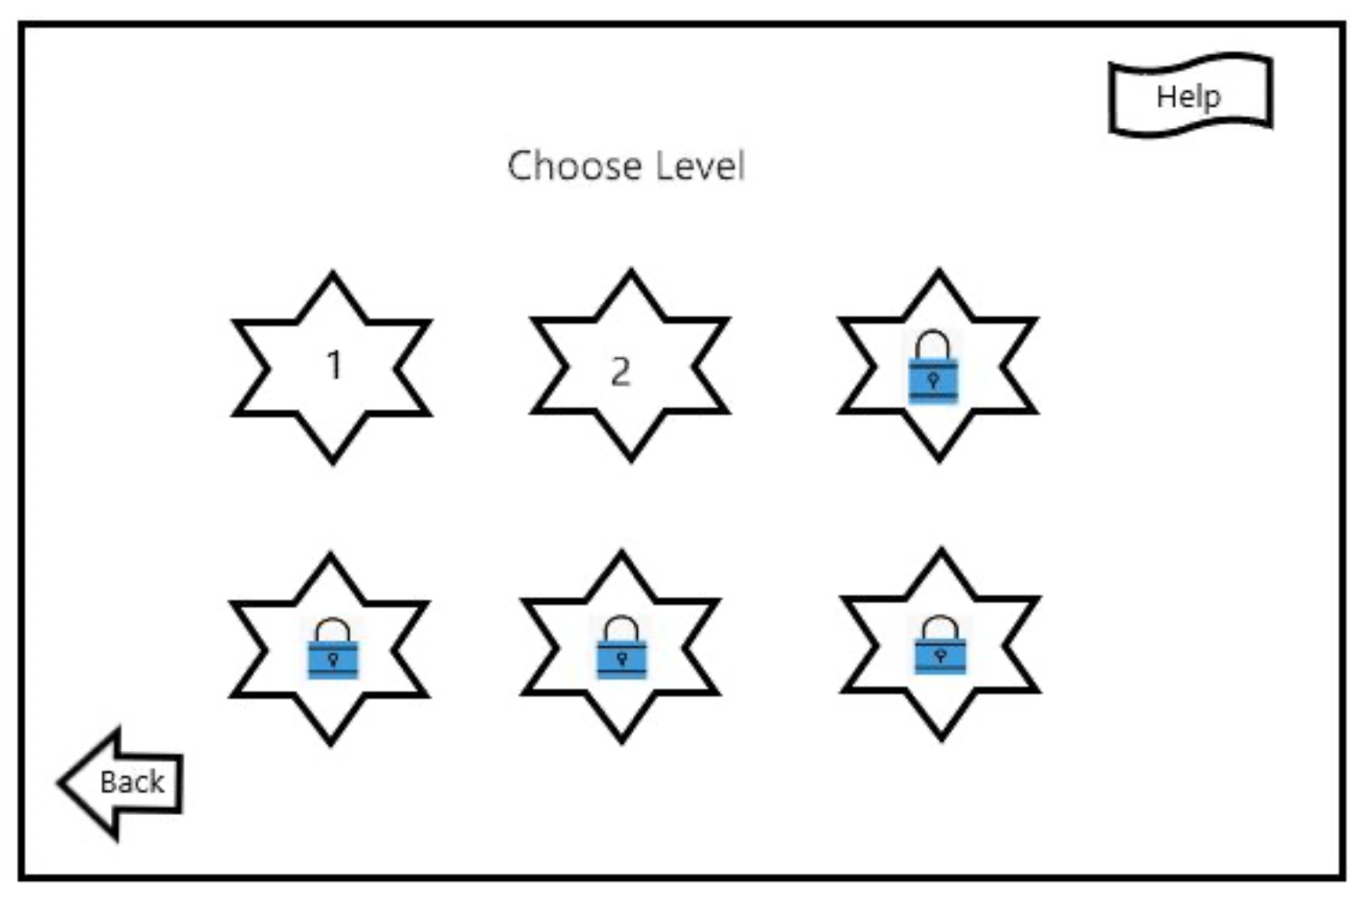

### UI of game failed

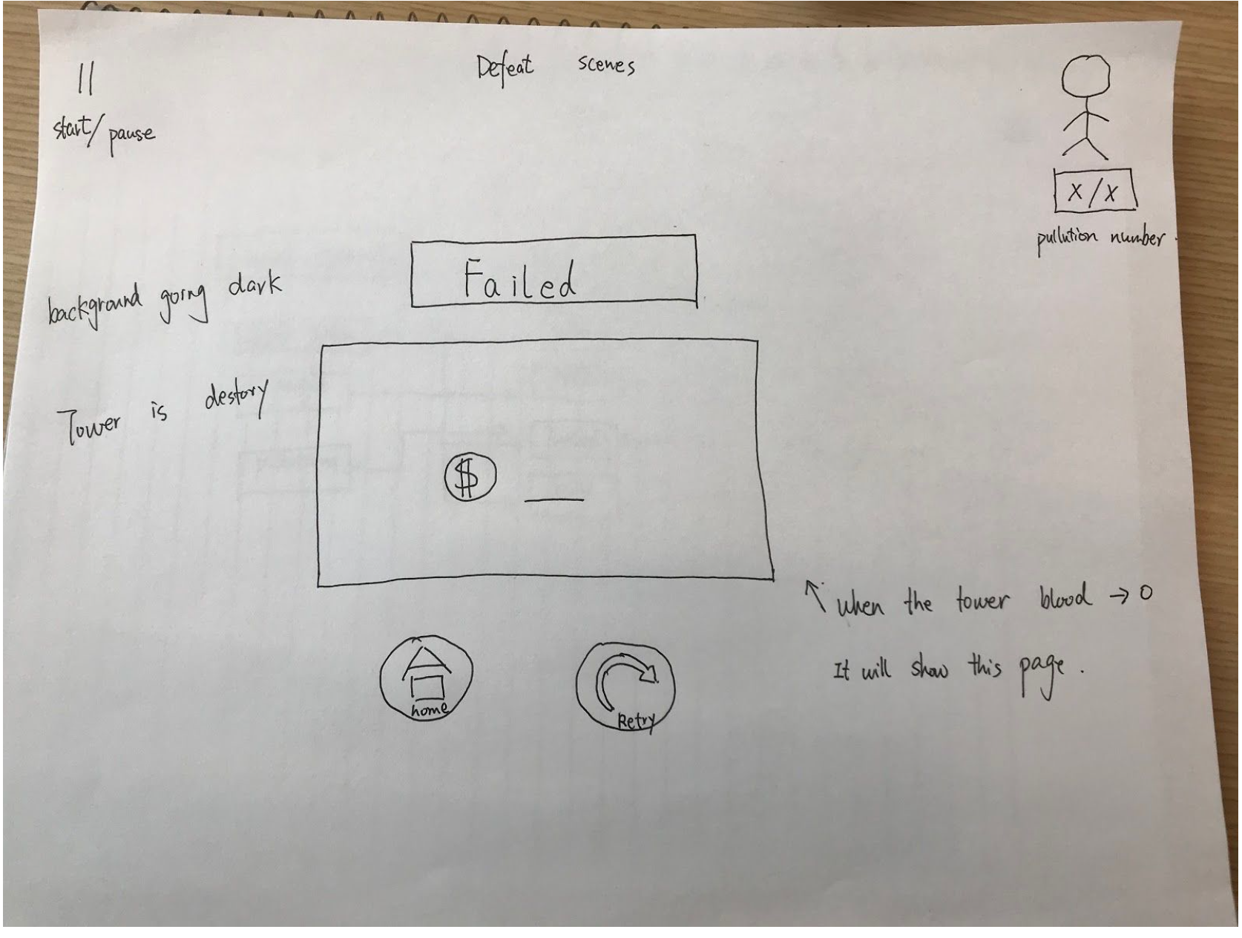

UI of game success 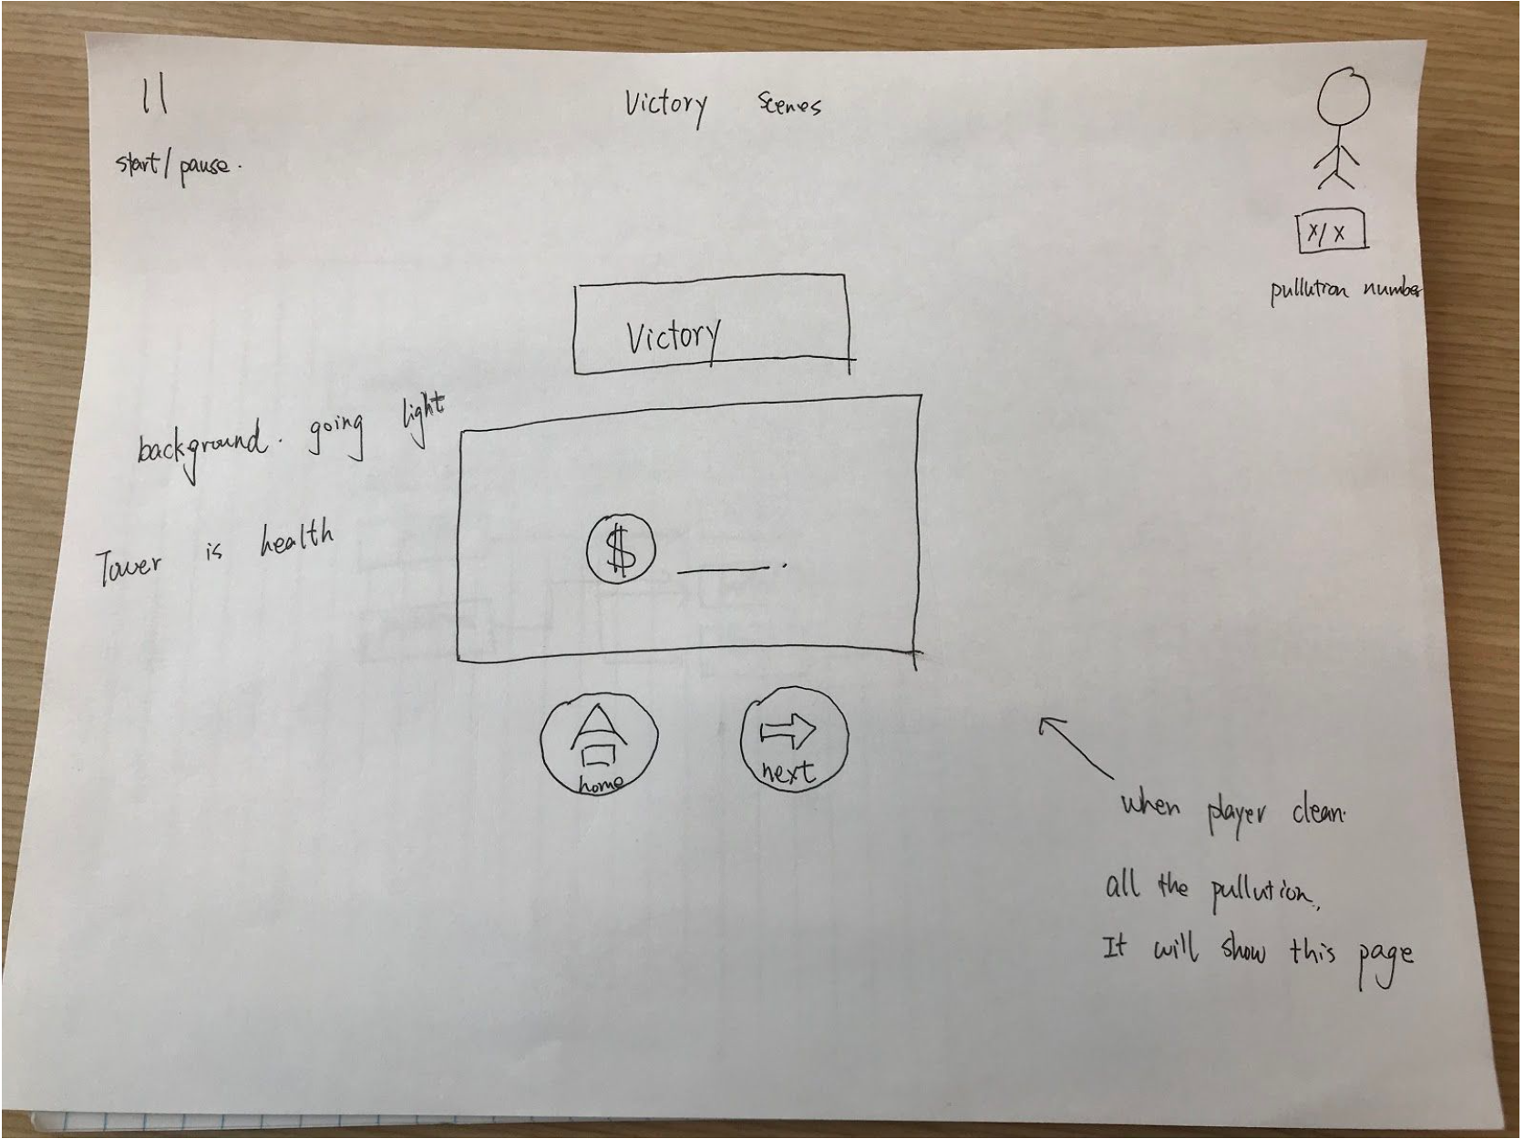

UI of game store

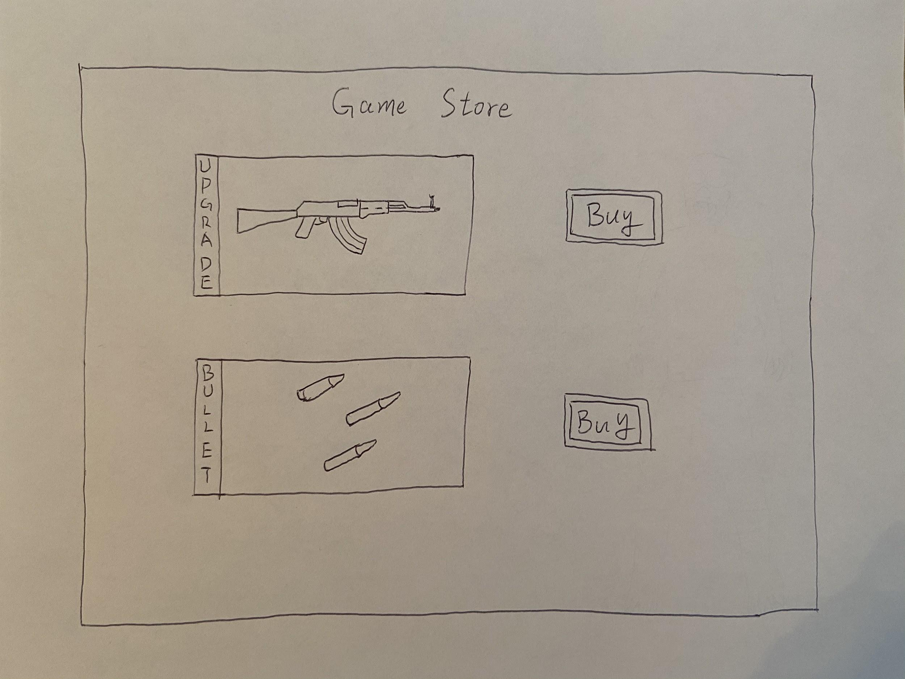

# 

# Section 3：Game Reflection

Karthik Karra:

Designed the game user interface include start page, level choosing page, victory/game over prompt. player will first see the game start page, click “start” button to get into the level choosing page, if player have never passed all the three game level, you can only choose the first level. Otherwise, player can choose any one of the three level.

Jiaxuan Che:

Designed the Enemy model, includes physical characteristics, their action and the effects of being killed. There are three types of enemies in total, different enemies have different amount of blood. Each game level corresponds to one kind of enemy. Player will encounter the primary enemy in first level, which are easiest to be killed, and encounter intermediate enemy in second level, and encounter senior enemy in third level, which have highest amount of blood and are hardest to deal with.

Bowen Yuan:

Designed and implemented the operation mechanism of the player. The character controlled by player can carry an automatic rifle to against the enemy and protect himself and the clean water resource. The player's perspective is first-person, and the character could move forward, backward, leftward and rightward by using the direction key. Firing the enemy by using the left mouse button.

Huaizhi Wang:

My responsibility is putting all the content together and making every parts include enemy, player’s character and the user interface fit together perfectly. In addition, I designed and will continue to improve the interaction mechanism between enemy and player’s character, the enemies would automatically chase and attack player, if they cannot get close to the player, they would choose to pollute the clean water.

Bhoami Khona:

Designed the user interface about the ammo purchasing, skills purchasing, ammo indication and money indication. When the player is fighting enemies in the game, they can earn money by killing enemies, and using the money to buy their rifle ammo and skills of killing enemies.

## 3.1 What We Are Most Proud Of

Karra: I am responsible for the UI interface design work. At the beginning of the game, we thought about many kinds of UI interface design. From the selection to the final decision, we spent a lot of time. To the end, we are very happy that the UI we designed is implemented in our project.

Che: I am proud of the game mechanism, because it achieves most of the function of a classical first person shooter game. Players can experience great joy when they play our game as they play other FPS game such as Call of Duty.

Yuan: I think our team's design idea is very good, which vividly reflects the theme of protecting water resources. Although there are some small regrets about the image of the game, such as the image of monster can best be replaced by the image of garbage, the overall idea is not bad.And it's a good idea to combine it with the popular genre of first-person shooting.

Wang: When I chose the theme at the beginning, I was very happy to choose the theme of protecting water resources. This is very convenient for us to find environmental models in the later period. The protection of water resources is a big problem in society. We hope to use the game method to wake up People's protection of water resources.

Khona: I am proud of the fluency of our game, as it is a FPS game, some people may feel dizzy because of the vivid environment and the characteristic, but it is not a problem when you play our game.

## 3.2.Changes to Original Game Design

Our initial design idea was to design a tower defense game, which combines the concept of protecting water resources through tower defense games, but due to technical reasons, we cannot achieve the game process of the tower defense game and the parabola problem of archers ’archery, so we Abandoned the design idea of the tower defense game and changed to the first-person shooter game. Compared with the previous tower defense game, the FPS game is not difficult to implement, plus we learned how to make survival shooter games on Unity The knowledge can be well used in the games we designed.

## 3.3.Learned from Playtesters

After testing the game, the game testers gave us a lot of opinions, because we are developers, we can draw different views from the developer's perspective and the game player's perspective. Summed up a lot of changes about the game. For example, for the setting and frequency of zombies 'blood volume, not many players can master the skills of shooting games very well, so we can't say that the frequency of zombies' appearance is adjusted quickly, and players who need to adapt to different hand speeds should try to play. For example, we can choose more distinctive styles for the models of zombies and character firearms.

## 3.4.What Changes would you make based on what you learned from Playtesting

We would add a settings module, in this module, players can modify the mouse speed, and adjust the volume of sound effective and background music, also player can choose turn off of all the sound. In addition, player can choose using what key on the keyboard to manipulate the character, such as you can use other keys to replace A, S, W, D to control the movements of the character. The second ting we would change is the map’s complexity, it will bring more joyment to our players.

## 3.5.If We Had More Time

We would design and add more weapons and skills system if we had more time. Such as pistols and grenades, these alternate weapons would extremely improve players game experience. All of the weapons can be purchased from the game store. Also we would like to implement a few powerful skills to help players win the game, for example, every once in a while players can choose to call air strike or emergency airdrop.

## 3.6.What We’d Do Differently

Karra: On the design of UI interface, we discussed many types of UI. We have disagreements on the choice of icons regarding the victory and defeat interfaces, but in the end I searched a lot of game information to understand which icons are these UI interfaces Often used, and finally everyone agreed to my plan.

Che: We would design some enemies with significantly pollution characteristics instead of some normal zombies. To be specifically, domestic pollution would be represented by a zombie carrying a bottle of dirty water or they can throw garbage which would pollute the clean water or cause damage to player. For the agricultural pollution, there would be some insects zombies which get killed by the pesticides. For the industry pollution, enemies would be either monster made by industrial material or metal robot, both of them can split fire or gas, and they are the most powerful enemies in the game.

Bowen: I am mainly responsible for the player's control of the character, including moving shooting and so on.In my opinion, the difficulty in this aspect is to have a clear design idea, and to have corresponding states for different events and operations, such as the loss of health when attacked.Therefore, it is necessary to let the player and the game have a clear and intuitive interaction, so that the player is easier to get started.

Khona: On the UI side, the most important things are clarity and aesthetics.The user interface is the part of the game that communicates directly with the player, and it is easy to confuse the player if there is unclear content.So it's important to choose the right colors and pictures, and also the right sound.

Wang: What I do is different is to integrate all the work results of everyone, so I need to communicate with everyone. There are many problems in this work. I need to solve problems in every link. Each of us will know this. The game has invested a lot of effort, starting from finding problems to find solutions in every detail, and finally completing the entire project.

# 

# Section 4: Playtesting Discussion

## Game Testing Rubrics

### Testing Method: Questionnaire

### Demographic Questions

1. What is your age?

A. < 18 age B. 18 - 24 C. 25-34 D. 35-44

1. What is your gender? ___________
2. What is your employment status?

A. Employed full-time C. Student

B. Employed part-time D. Other

1. What is your degree of education?

A. Collage B. Master C. Doctor D. Other

1. Where are your from?____________

### Tasks List

1. Control character movement: W, A, S, D
2. Control character crouch down & jump: C & Space
3. Open store: N
4. Open fire: Left Mouse Button

### Game Questions

Please specify your rating for the following aspects (Degree of satisfaction:10-1 )

|  |  |  |  |  |  |  |  |  |  |  |  |
| --- | --- | --- | --- | --- | --- | --- | --- | --- | --- | --- | --- |
|  | Question | 10 | 9 | 8 | 7 | 6 | 5 | 4 | 3 | 2 | 1 |
| 1 | Do you like this game？ |  |  |  |  |  |  |  |  |  |  |
| 2 | Does the navigation seem clear? |  |  |  |  |  |  |  |  |  |  |
| 3 | Does this game UI seem clear? |  |  |  |  |  |  |  |  |  |  |
| 4 | Was the game easy to begin? |  |  |  |  |  |  |  |  |  |  |
| 5 | What do you think of the challenge of the game? |  |  |  |  |  |  |  |  |  |  |
| 6 | What do you think of the educational nature of the game? |  |  |  |  |  |  |  |  |  |  |
| 7 | Do you think the fluency of the game？ |  |  |  |  |  |  |  |  |  |  |
| 8 | Would you recommend this game to others？ |  |  |  |  |  |  |  |  |  |  |

### Post Question

1. What was your favorite moment or aspect of this game?
2. What was the hardest aspect to understand (i.e. were any of the rules unclear)?
3. What other operating ideas do you have for first-person shooting games？
4. How did this game make your feel while you played it?
5. If you could change anything from the game, what would it be and why?
6. Did the graphics and audio enhance the game? If not, please explain?
7. What do you think the idea combine clean water with FPS game?
8. Additional Comments / Feed

## Feedback of survey results

Each of team member found 4-6 testers for the Feedback. We total have 26 people finished this Game Testing Rubrics.

### The Result of Demographic Questions

# 



### The Result of Game Question

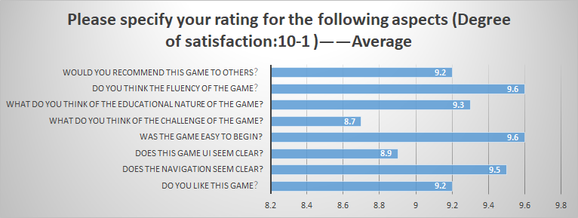

### The Result of Post Questions

Representative proposal

What was your favorite moment or aspect of this game?

1. some players like the whole environment.
2. some players like upgrade the gun, when you earn 1000 gold you will get a new gun.
3. some players enjoy shooting zombies.

What other operating ideas do you have for first-person shooting games？

1. Characters can have skills that are more fun to work with.
2. Zombies can have some ranged attack abilities

What do you think the idea combine clean water with FPS game?

It's a good idea, and the form of the game is good.It would be nice if the theme of water conservation could be more visually reflected in the game, such as replacing the zombie image with some junk image.

How did this game make your feel while you played it?

1. exciting, they are very exciting to kill zombies.
2. boring, the less kinds of zombies and model.
3. interesting, as the level increases, the types and difficulty of zombies are escalating.

Additional Comments / Feed

1. Should create more level.
2. We can design multiplayer mode.

# 

# Section 5: Reference — P4 Bibliography

## 

### Jiaxuan Che

Artificial Intelligence for Adaptive Computer Games

<https://www.cc.gatech.edu/faculty/ashwin/papers/er-07-04.pdf>

The technology of Artificial intelligence has been more and more applied to the computer games and other applications. Computer game developer and companies hope AI can play a critical role in the game industry. In this paper, the author is mainly talked about challenges and opportunities of technology that can be used in developing computer games. There are three major approaches to implement adaptability in games, which are automatic behavior adaptation for believable characters; drama management and user modeling for interactive stories and strategic behavior planning for real-time strategy games.

Some of the most essential challenges when applying AI to game development includes: Complex decision spaces, knowledge engineering, Authoring support, Unanticipated situations, Unanticipated situations, replay ability and variability, Rhetorical objectives. In a word, not only can games benefit from better AI techniques, but AI can also benefit from the challenges that computer games provide.

Behavior modification for believable characters AI is that game developer often uses scripts to describe the game character’s interaction with the game world, and these characters have their own personality and behavior which can influent the way they contact with the game. Case based planning for strategy games is that game developer has to use contribute reasonable effort to develop the game due to the game require the vast search spaces for game characters. As for the drama management in interactive stories, there is an arising interest in developing Drama Manager components that enable the game player to move to a story ending that exhibits a narrative arc. The goal of these components is to allow the player to have significant impact on what happens during the interaction.

### Bowen Yuan

Player-Centred Game Design

Author：Jonathan Sykes; Melissa Federoff

<https://dl.acm.org/doi/abs/10.1145/1125451.1125774>

Summary:

This article describes how to identify techniques for game design and demonstrates how to best apply a user-centric methodology to game design.

Video games are different from other business applications. Their focus is not on productivity and product safety, but on the player experience. A review of the design process found that game developers rarely consider the target audience, and often find that game designers do not trust user perceptions and tend to design products for their own enjoyment. Perhaps this is why the industry ’s traditional concepts tell us 80% Reasons for the failure of the published games to generate profits. Game design usually involves four different stages-concept development, pre-production, production and post-production. Applying user-centric design (UCD) in all four stages can yield significant benefits.

Development concept: In a market-oriented environment, the target audience will have many design constraints. There are many UCD technologies, such as user provisioning methods that allow game designers to gain insight into the gaming experience that their target audience appreciates most. When multiple design paths are possible, using experimental methods to evaluate responses to them can help game design teams make informed choices.

Pre-production: The design team will expand the game concept during the pre-production phase and develop a vertical prototype of the game. Apply expert assessment during pre-production and use participatory design, and usability and playtesting of the prototype with the target audience.

Production: Much of this work revolves around getting information from consumers during the production phase of development. Several techniques are often used: game tests that quantify the emotional response of a game, and usability tests that detect problems in the game.

Post-production: With post-production, the game will be evaluated by countless reviewers, which may be a great opportunity to collect user feedback on the sequel.

### Huaizhi Wang

The Importance of a Well Defined Core Gameplay Loop

<https://gamasutra.com/blogs/JoshBycer/20200306/359140/The_Importance_of_a_Well_Defined_Core_Gameplay_Loop.php>

Summary: The production of the game will become more and more perfect over time, but the core of the game is the important point that we have always discussed. Generally, a game's design plot is divided into two parts, one is micro and the other is macro. Micro represents a series of small tasks in the game process, and the macro goal is the main goal of a game. Today's game developers often only pay attention to the micro the development of the details neglected the positioning of the main game goals, leaving gamers unable to find the real and core points of the game.

How to make a game more interesting is the core point of a game, and it is important for players to understand the core game loop in a short time. The loop of the core game can attract players' attention and let them in a short time Learn about the general part of this game. In games such as Mortal Kombat and Counterstrike, the duration of the game cannot exceed one hour. Instead, matches are usually set up within a short time frame and each new match is repeated.

There are four things to compartmentalize a playthrough, 1.what is the near-term goal? 2. what tasks need to be completed? 3.how long does it take? 4. what kind of permanent progress has been made? At the beginning of each game's MMOG, players start from a simple game and simply complete the mission, gain experience points and unlock the next mission. If a player loses interest before reaching the goal, the game loses many players and causes failure. Therefore, when we are creating a game, we need to develop a special core game loop of the game. Whether it is a short-term task in the early stage or a long-term open world in the later period, we must keep the player's interest and enthusiasm for the game. Stay longer in the game to learn more about the fun you get from playing the game.

Common: This is the first time I understand the concept of game design, the core game loop of the game. He uses some simple examples to design, implement and test the CGL process. He may be helpful for the entire game development, but it does not It needs to be too long or complicated, as long as it appears to be well-designed for the new game. And in the process of designing CGL, we need to actually understand the level of attention that players pay to the game. Developers need to be physically aware of the player's feelings before they can develop a suitable game CGL.

### Karthik Karra

Bibliography (Game Design and Development)

Summary: This paper covers the main aspects of the game design and development. The factors that influence these features, MDA framework (Mechanics, Dynamics, and Aesthetics of Game design) etc. MDA is a formal approach which acts as a bridge between game design, development, game criticism and technical game research. This method strengthens the process of developers, scholars and researchers so that the evidence provided by them to the world would be easier to understand, conclusive and reliable.

Games are created by designers, group of developers, and are consumed by players. MDA framework formalizes the consumption of games by breaking them into their distinct components (rules, system, and fun) and establishing their design counterparts (MDA). So, MDA fundamentally tells us that games are more like artifact than media. Which means that content of game is its behavior rather than media. Thinking in way makes it clear that games are designed artifacts and helps systems to build behavior via interaction. When looking the game from designer’s perspective, we conclude that the mechanics give rise to dynamic system behavior which in turn leads to particular aesthetic experiences. So, for a better outcome of game, designers and players perspective are taken into consideration which helps in looking at the small changes in each layer which can start the change reaction into other.

So, MDA supports a formal, iterative approach to design and tuning. It allows to explicitly identify design goals and anticipate how changes will impact each design and implementation. By, looking at the three abstraction levels of MDA we conceptualize the dynamic of game systems. Understanding games as dynamic systems helps us develop techniques for iterative design and improvement and allowing us to control for undesired outcomes, and tune for desired behavior.

References

Hunicke, Robin, Marc LeBlanc, and Robert Zubek. "MDA: A formal approach to game design and game research." Proceedings of the AAAI Workshop on Challenges in Game AI. Vol. 4. No. 1. 2004.

### Bhoami Khona

Benefits of Video Games

Many people think that video games are not only a waste of time, money, and energy but also that they promote aggressive, violent, and antisocial behavior. On the contrary, these video games have the ability to improve humans in various aspects according to “9 Ways Video Games Can Actually Be Good For You” by Huff Post.

This article mentions a study conducted by German researchers where these researchers asked 23 adults with a median age of 25 to play “Super Mario 64” for 30 minutes every day for the period of 2 months. A separate control group was asked not to play video games at all. After 2 months the researchers examined the brains of people in both groups using MRI machines and they found that the people who were playing video games had risen the gray matter in the right hippocampus, right prefrontal cortex, and the cerebellum parts of the brain. These areas of the brain are responsible for spatial navigation, memory function, strategic planning, and fine motor skills in the hands. Increase in gray matter indicates development of the brain thereby confirming that video games are beneficial.

This article also mentions how playing video games makes the player smarter, slow the ageing process of the brain, help dyslexic people read better, improve surgery skills, act as pain reliever, improve eyesight, effective one on one counsellor, and help stroke victims to fully recover. Essentially, this article mentions the studies that have proven all of this to be true and cites them.

Bibliography:

Guarini, Drew. "9 Ways Video Games Can Actually Be Good For You." The Huffington Post. TheHuffingtonPost.com, 07 Nov. 2013. Web. 25 Apr. 2016. <http://www.huffingtonpost.com/2013/11/07/video-games-good-for-us_n_4164723.html>.